*Creating a Game Idea:*

When coming up with a game Idea, I struggled on deciding what type of mobile game I would like to make. Part of the struggle was coming up with an idea that would reasonably incorporate two of the three technologies required in the specification. I also was not keen on the theme of “Treasure Hunt” which was detailed in the ICA document. However, when I spoke to module leader *Julien Cordry,* he assured me that this is not a requirement, and the theme could be anything. Knowing my previous errors when creating 2D games, I decided to start by finding a sprite pack that I liked the look of and create a game from the resources I could find.  
  
*Sprite Pack and How It Prompted my Idea:*

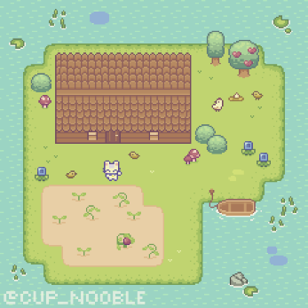Looking online, I found that Itch.io was a good source for getting free or paid sprite packs. One I liked in particular was called “Sprout Lands” created by “Cup Nooble” (<https://cupnooble.itch.io/sprout-lands-asset-pack>). I liked this pack because, although it is still in development, there were a lot of assets available, and it was very cute and aesthetically pleasing to look at. They had both a free version which had limited assets and limited licensing, or a paid version which had access to all assets and commercial use licensing, so I opted for the latter.

Sample Images taken from <https://cupnooble.itch.io/sprout-lands-asset-pack>

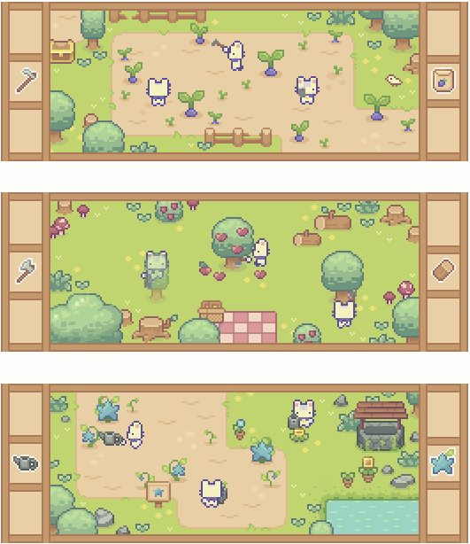

Because of the assets available and the animations, it was clear to me that this would make for a cute small farming game. Thus began the planning of my game idea.

*The Idea:*

The base idea for this game is a small Island with areas set for farming crops. I want to keep my scope small and concise to ensure I make a fully functioning game that is simple and easy to use for players. Although the asset pack I have purchased has a lot of possibilities, I will focus on simple planting, watering and harvesting. If I have time spare and wish to stretch my goal, I may look into adding animals (there are cows and chickens available), and perhaps trees to fell and/or harvest from (e.g. apple trees). These would likely also add either a bridge to another island with these elements on or look at adding the boat asset that is available in the asset pack to travel to another Island.

*Technology:*

The technology I intend to use include “Touch Gestures” for moving the player character around, interacting with world events such as planting, and interacting with the UI (HUD and Menus). I also intend on using GPS to get the user’s approximate location and use that to access the local weather report and reflect that in the game. So for example, If it is raining or gloomy in the real world (Precipitation likeliness is 50% or higher), there will be rain in the game and players do not need to water the plants. As a stretch goal, I am thinking of looking at the real-world date and setting some crops to seasonal only. This means that when you are in the right season in real life, you can plant specific crops such as pumpkins during the month of October. The only issue with this is that it may take away some of the enjoyment to the game although it will show good use of technology.

*UI:*

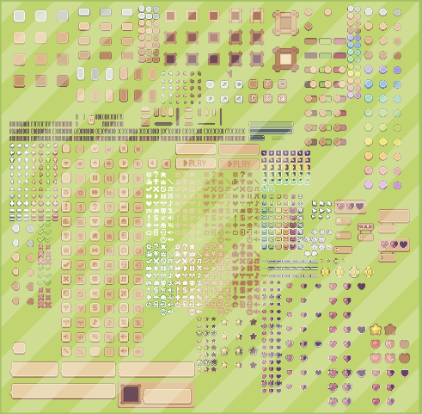Quite luckily the asset pack I found has an extension pack for UI assets which I will be using since it will match the style of the game nicely (<https://cupnooble.itch.io/sprout-lands-ui-pack>). The biggest use of this asset pack will be aimed more towards the menu systems and option changes, however there will be a small HUD element to display currency and amount of seeds the player has. There will also be tutorial prompts for the first few minutes of the game and I hope to include a pop-up inventory system for some sort of storage space (e.g. a Barn). For displaying weather elements, it is quite likely I will need to create my own sprites for that but I intend to make it tileable and there will only be rain and maybe snow. As a stretch goal I may add leaves for windy but not rainy days, coloured to the current season.

Sample Image taken from <https://cupnooble.itch.io/sprout-lands-ui-pack>

*The Plan/Layout:*

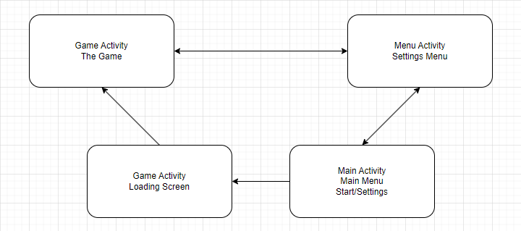

My plan for this is to have the Main Activity as the Main Menu as this will be the first thing to load, although as I move along in my production, I may find that it would be better to load the game data first, then activate the Main Menu when the load is complete. From the Main Menu we will be able to load the Setting Menu activity, and closing this would return us to the Main Menu if that was the previous activity loaded. We can also select to start the game from the Main Menu which will activate (Unless I switch the order here) the loading activity which will load any previously saved game data, before automatically opening the Game Activity upon a successful load. From the Game activity players can control the player character and play the game, but also be able to select the Settings menu which will open the settings activity. From there we can return to the game if the Game activity was the last activity open.   
  
As I already have access to such a detailed and well laid out asset pack, I expect this won’t take me an extreme amount of time. I will be aiming to complete my core functionality by mid-November with the hopes of either polishing up or adding a stretch goal if the game is already polished, making sure the game is ready in time for the submission date with little to no issues and a fully working game.